**Give an Image a Perfect Round Shape Using Word and Paint**

It’s frustrating that there is no option whatsoever to [crop an image](http://www.guidingtech.com/14884/reduce-photo-size-crop-before-uploading-android/)**in round shapes** on [MS Paint](http://www.guidingtech.com/15171/ms-microsoft-paint-keyboard-shortcuts/). And I just hope that Microsoft will introduce such a feature sometime or the other. Till then we have to live with workarounds or use tools like Photoshop (that’s the best I can name). But then, we deserve an easier way out right?

Today we plan to discuss a cool trick to help us give an image a complete round shape easily using Paint and Word. It may not seem like an exact crop activity, but the result is good enough. And then you may save the resulting creation as an independent image or place it over some [background](http://www.guidingtech.com/11633/os-x-lion-customize-desktop-background-wallpaper-slideshow/). Here’s how to do that.

**Steps to Crop a Round Shape Using Word and MS Paint**

We are going to take help of MS Word here. The concept comes from the fact that we can**insert images within a shape** that we create on MS Word (or [even PowerPoint](http://www.guidingtech.com/14160/align-shapes-pictures-powerpoint-2010/)).

**Step 1:** Open the base image from which you want to crop a circular section. Crop a rectangular section on the area that you visualize for a round crop shape. Save this crop as an independent image. Here’s the sample crop that I saved.

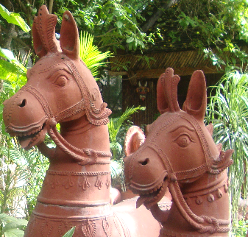

**Step 2**: Open MS Word. Navigate to *Insert*  tab -> *Shapes*and choose *Oval* (ellipse).

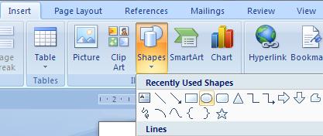

**Step 3:** On the MS Word canvas draw the shape with the size that you want. Hold **Shift** while drawing the shape; it helps to create a perfect circle.



**Step 4:** Keep the shape selected. *Drawing Tools* will get activated with a *Format* tab under it. Switch to Format and then choose Shape *Fill -> Picture*. Choose the picture that you saved in Step 1. Your picture will be inserted and contained flawlessly within the shape.

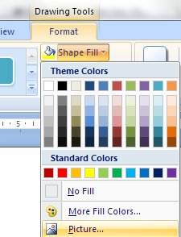

**Step 5:** Right-click on the shape and select *Format AutoShape*. Our aim here is to remove the shape border.

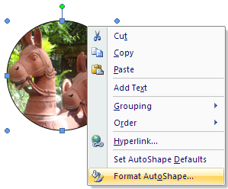

**Step 6:** Ensure to be on the *Colors and Lines* tab. Under*Lines* section, go to *Color* and select *No Color*. Click on*Ok*when you are done*.*

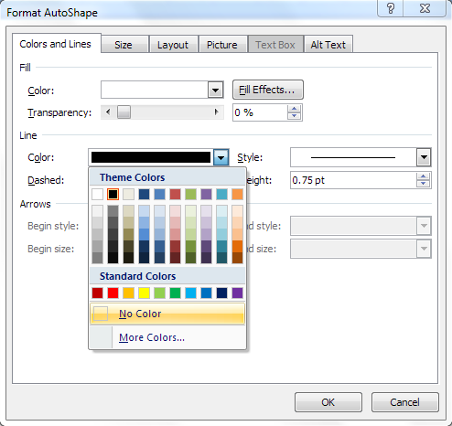

**Step 7:** Right-click on the resulting shape and *Copy* it on to the clipboard. You may do a Ctrl + C as well.

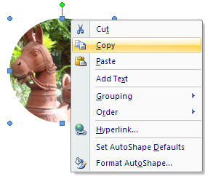

**Step 8:** Go back to MS Paint and paste the contents of the [clipboard](http://www.guidingtech.com/14983/ditto-portable-copy-paste-clipboard-manager/) there. You may now save the image.

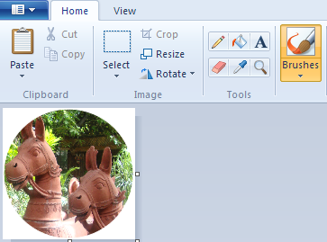

If you plan to paste this over a different background (other than white) make sure that *Transparent selection*is on before you paste the image.

